1. Golden Rules
- Always test your code!
- Use Google! ESPECIALLY if you don’t know or can’t remember something
  - DO NOT OVER-GOOGLE (do not pass page 2 of results)
  - DO NOT USE CODE YOU DO NOT UNDERSTAND
  - DO NOT COPY PASTE FROM GOOGLE! (read the code, understand it, and recreate it your own way)
- Make mistakes! Seriously, don’t be scared of making mistakes. The worst thing that can happen is you go back and fix it. Mistakes are a great way to learn (it’s called trial and error for a reason).
- Good code is lazy and efficient! Efficiency and laziness go hand in hand.
- Ask your classmates! There is no shame in not knowing something or asking for help. Leverage the community!
- Hop in the queue! If you get stuck on something for 15 minutes or more, ask us.
- Never overestimate how much time you have!
- Don’t Panic!
- Don’t run terminal commands you don’t know!
- Static code is illegal code!

2. Coding Concepts

2.1 Types And Declaration

2.1.1 Declaration
- Create a new variable of a specified type
- Create a new function

Type | Purpose | Screenshot
const | - Declaration of an immutable variable.  - Value of the variable CANNOT change. It is permanently assigned at declaration.  - It is the default declaration type. | 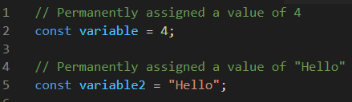
let | - Declaration of a mutable variable.  - Value of the variable can be changed at any time. | 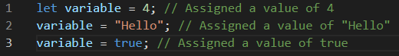
var | - Declaration of a mutable variable.  - Value of the variable can be changed at any time.  - var is hoisted to the top of the code by the compiler (this is bad).  - WE WILL NOT BE USING THIS DURING THE BOOTCAMP! | 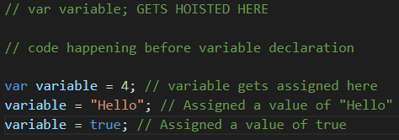
function | - Declaration of a function.  - Functions execute their code only when they are called.  - Code inside the function does not exist until the function is called and stops existing once it finishes.  - function is hoisted to the top of the code by the compiler (this is bad). | 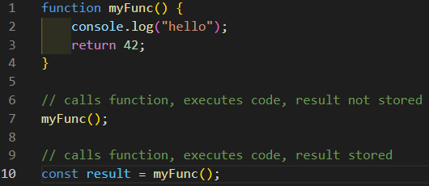
Arrow function:  () => {} | - Declaration of an arrow function.  - Arrow functions MUST be stored inside a variable to be named.  - const is the preferred storage type (functions are not meant to change).  - New syntax for writing functions.  - Arrow functions execute their code only when they are called.  - Code inside the function does not exist until the function is called and ceases to exist once it finishes.  - Arrow functions are function expressions. Technically not real functions. | 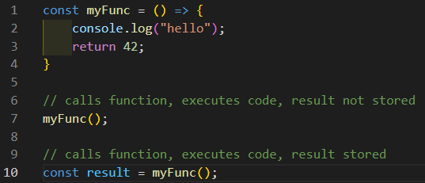

2.1.2 Types

Type | Use | Screenshot
string | - Anything inside a string is considered plain text (numbers, symbols, etc.).  - Strings can be defined by using quotes.  - The three types are :  - " " (double quote)  - ' ' (single quote)  - ` ` (backtick)  - Backticks have a super power called interpolation, allowing you to insert Javascript directly into the string. | 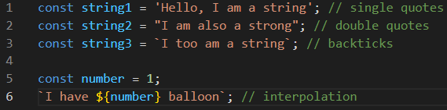
number (integer) | - An integer is a number.  - It has no decimals. It is always rounded (up or down). | 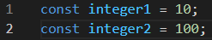
number  (float) | - A float is also a number.  - It has decimals. | 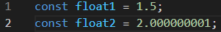
boolean | - Mutable variable that only contains a value of true or false.  - Often referred to as flags.  - Can be used to check conditions. | 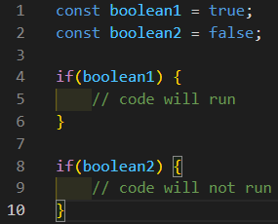
true | - Coding representation of true.  - Used in condition checks. | 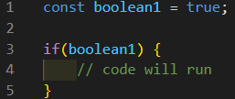
false | - Coding representation of false.  - Used in condition checks. | 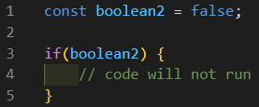
GLOBAL | - Global is not a real type, it is a declaration convention.  - GLOBAL variables are declared at the top-most level to be accessible by any other parts of the code.  - GLOBAL variables are type const by convention and used as parameters in the code.  - GLOBAL variables are capitalized by convention and words are separated by an underscore. | 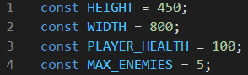
array  [] | - An array is literally a list.  - Arrays are a type of object in JavaScript.  - It is used to store data.  - Arrays are denoted by square brackets.  - Arrays can contain any other type inside them (and they can be mixed). | 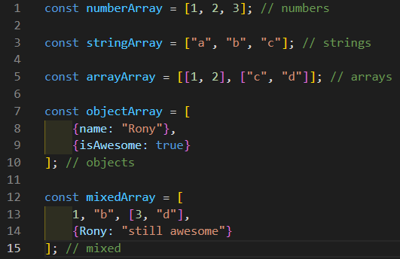
object  {}  {key:value} | - An object is used for data storage.  - Objects are often used for big amounts of data.  - Objects are denoted by curly brackets and key:value pairs.  - Objects cannot be iterated on directly.  - Keys do not need to be strings. JS will automatically convert them.  - Values can be any type. | 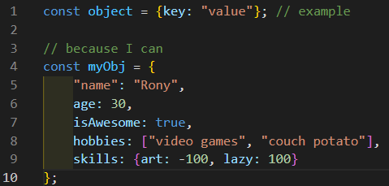
function | - Functions (both arrow and classic) are blocks of code executed on demand.  - They can be passed arguments when the function is called.  - Passed arguments are stored inside function parameters upon activation (after being called).  - The code inside a function is not executed until the function has been called. | 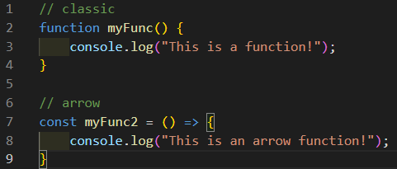
method | - Referred to as "dot methods".  - A method is a built-in Javascript function that is called by using the . operator.  - They take () after being called because it follows the same rules as a function call and often requires parameters  - ONLY EXCEPTION TO THIS IS THE .length METHOD (that I know of) | 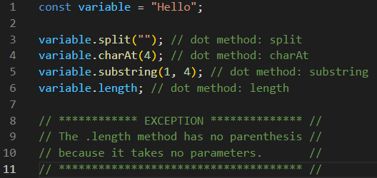
loop | - Loops are a block of code that will run until their condition becomes false. | 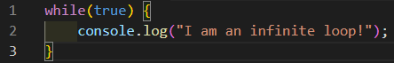

2.2 Operators

2.2.1 Assignment Operators
All assignment operators share the following properties:
- They cannot be used in a condition.
- They are used to assign a new value to an existing variable.

Type | Use | Screenshot
= | - Assigns a new value to a variable.  - The only assignment operator that can be used at variable declaration. | 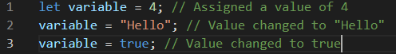
+= | - Assigns a new value to a variable through addition.  - Removes a number from the previous value and assigns the result to the variable.  - Shorthand for variable = variable + number. | 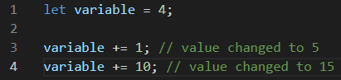
-= | - Assigns a new value to a variable through subtraction.  - Removes a number from the previous value and assigns the result to the variable.  - Shorthand for variable = variable - number. | 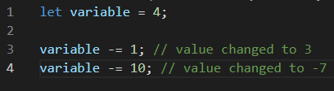
*= | - Assigns a new value to a variable through multiplication.  - Multiplies the previous value with a number and assigns the result to the variable.  - Shorthand for variable = variable * number. | 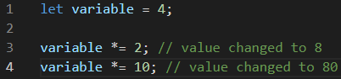
/= | - Assign a new value to a variable through division.  - Divides the previous value with a number and assigns the result to the variable.  - Shorthand for variable = variable / number. | 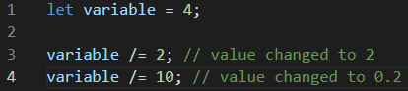
%= | - Assign new value to a variable through modulo.  - Modulo divides the previous value with a number and assigns the result to the variable.  - Shorthand for variable = variable % number. | 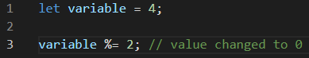

2.2.2 Arithmetic Operators
No I don’t expect anybody needs most of this, but it’s good to remember that in code, simple mathematics are considered operators.

+  (Addition) | - Adds two numbers together and returns the result.
-  (Subtraction) | - Removes the number on the right from the one on the left and returns the result. | 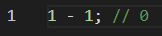
*  (Multiplication) | - Multiplies two numbers together and returns the result.
/  (Division) | - Divides the number on the left with the one on the right and returns the result. | 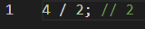
%  (Modulo) | - Divides the number on the left with the one on the right and returns the remainder as the result.  - The remainder is what is left after the division (no decimals). | 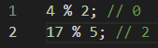  - 4 % 2 is 0. No remainder is left because 2 * 2 = 4.  - 17 % 5 is 2. Remainder of 2 is 17 - (3 * 5) = 2.
++  (Increment) | - Increments the value of the variable by 1.  - Order in which it appears matters (except in a for loop).  - If the ++ operator is placed in front of a variable, it will be executed before anything else on the line.  - If the ++ operator is placed behind a variable, it will be the last thing to be executed on that line. | Before: changes value before executing code.  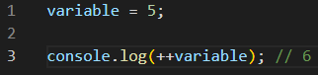  After: changes value after executing code.  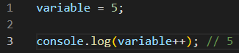
--  (Decrement) | - Decrements the value of the variable by 1.  - Order in which it appears matters (except in a for loop condition).  - If the -- operator is placed in front of a variable, it will be executed before anything else on the line.  - If the -- operator is placed behind a variable, it will be the last thing to be executed on that line. | Before: change value before executing code  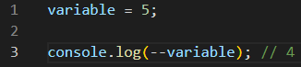  After: changes value after executing code  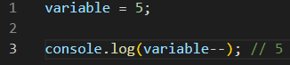

2.2.3 Comparison Operators
All comparison operators share these two properties:
- They are used in conditions.
- They return true or false as a result of the comparison.

Type | Use | Screenshot
==  (is equal to)  (soft) | - Soft check (x equal to y).  - Compares values of elements on both sides. | 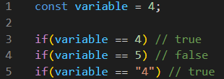
===  (is equal to)  (hard) | - Hard check (x equal to y).  - Compares values AND types of elements on both sides. | 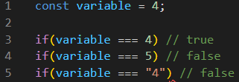
<  (smaller than) | - Checks if the element on the left is smaller than the element on the right. | 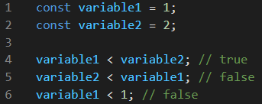
<=  (smaller than or equal to) | - Checks if the element on the left is smaller or equal to the element on the right. | 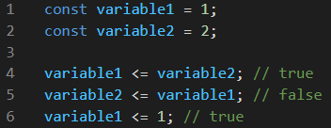
>  (greater than) | - Checks if the element on the left is bigger than the element on the right. | 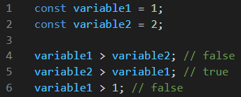
>=  (greater than or equal to) | - Checks if the element on the left is bigger or equal to the element on the right. | 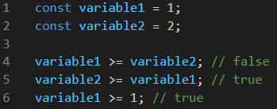

2.2.4 Logic Operators
Logic operators are used in conditions.

Type | Use | Screenshot
&&  (and operator) | - Returns true only if both sides are true.  - Returns false if a single or both sides are false. | 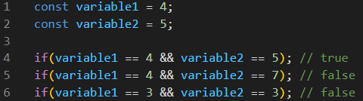
||  (or operator) | - Returns true if a single or both sides are true.  - Returns false only if both sides are false. | 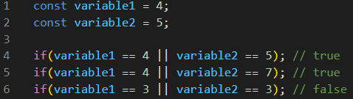

2.2.5 Not Operators
***Not operators are also comparison operators, but get their own section***
All not operators share these two properties:
- They are used in conditions.
- They always look for the opposite result.

Type | Use | Screenshot
!  (not operator) | - Always returns the opposite result.  - true becomes false.  - false becomes true. | 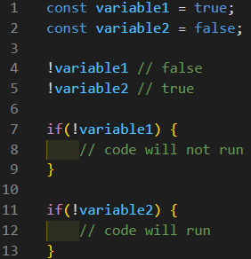
!=  (not equal to)  (soft) | - Soft check (x not equal to y).  - Similar to ==, only compares the values of elements on both sides.  - THIS IS ALSO A COMPARISON OPERATOR. | 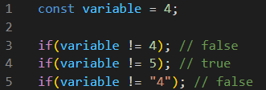
!==  (not equal to)  (hard) | - Hard check (x not equal to y).  - Similar to ===, compares values AND types of elements on both sides.  - THIS IS ALSO A COMPARISON OPERATOR. | 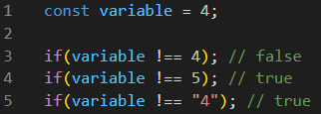

2.2.6 Conditional Operators

Type | Use | Screenshot
if | - A condition must be specified.  - Always checks to see if the condition is true.  - Code inside the if will only execute if the condition is true.  - CANNOT ASSIGN INSIDE A CONDITION (= is not allowed)! | 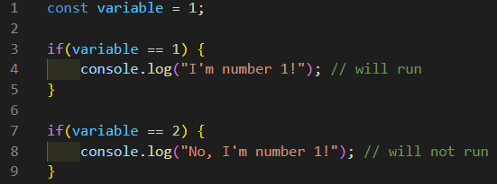
else if | - Can only occur after an if operator.  - Offers an alternate condition check if the previous one has failed.  - Can chain as many as needed. | 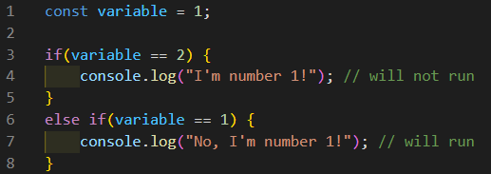
else | - Can only after an if or an else if operator.  - Else will run ONLY IF all other condition checks have failed.  - Marks the end of the if/else if chain. | Will run:  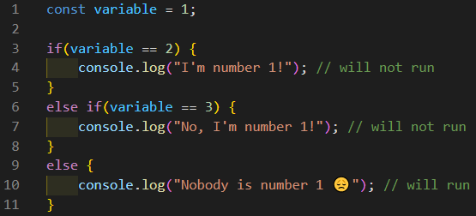  Will not run:  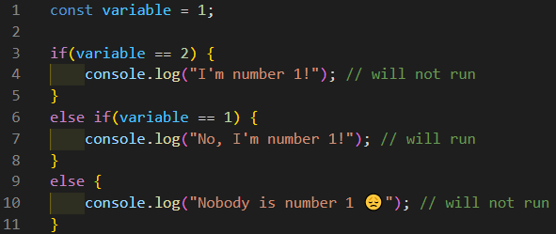

2.2.7 Other Operators

.  (dot) | - Structure: variable.method().  - Used to call built-in javascript commands (methods). | 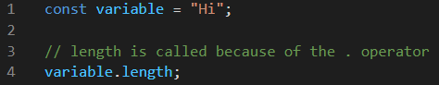
...  (spread) | - Can only be applied to arrays or objects.  - Only returns the CONTENT of the object it is applied to.  - To create a new array or object using the spread operator, it must be encased in the appropriate brackets. | Array:  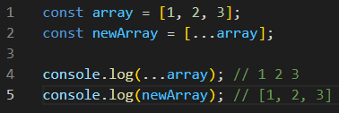  Object:  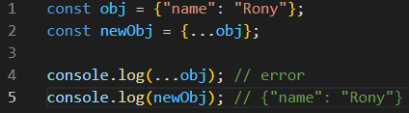
...  (rest) | - Can only be used within the context of a function that receives an indeterminate number of parameters.  - Captures all the passed arguments into a single array parameter. | 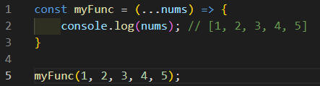
?  (ternary) | - Special operator that replaces an if/else statement.  - condition ? result if true : result if false.  - For an if/else if/else, nest a second ternary inside the first’s false result. | 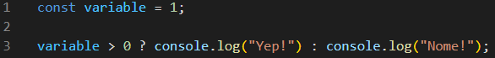

2.3 Array Specifics

2.3.1 Array Index

Concept | Use | Screenshot
Array index | - The index of an array ALWAYS starts at 0.  - The index of an array ALWAYS stops one number before the actual length of the array (numerically).  - The first element is index 0, the second is index 1, the third is index 2, etc..  - The final index of an array is ALWAYS (numerically) the length of the array - 1
Accessing a position | - To access an element at a specific position, the array must be called with a number (or a mathematical operation resulting in a number) inside the brackets.  - The first element is always at index 0.  - The last element is always at index array.length - 1. | 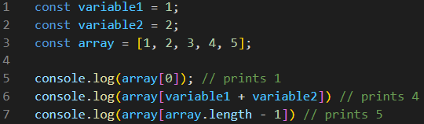

2.3.2 Complex Array Methods
***There are more than just these 5 array methods.***
Array methods all share the following properties:
- They all take a callback function.
- The callback function MUST have a parameter.
- That parameter is the current single element the method is iterating on.
- Because it is iterating on a single element, its name will be singular. THIS IS A NAMING CONVENTION!
- Complex array methods are significantly faster than regular loops!

Method | Use | Screenshot
.forEach | - Loops over an entire array.  - Good for changing the value of a variable that depends on the contents of the array.  - Ex: counter  - Ex: flag  - CANNOT RETURN ANYTHING, EVER!  - If you put a return inside, it will ALWAYS return undefined, no matter what. | 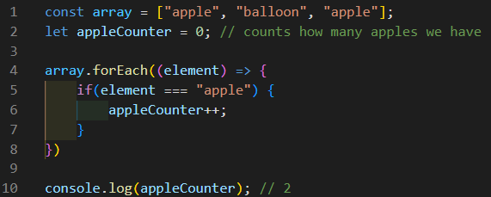  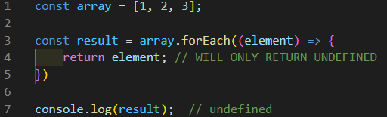
.map | - Loops over an entire array.  - Good for changing/modifying all contents of an array.  - Return statement can be an operation or a value.  - Returns a new array of the same length as the original with affected results | 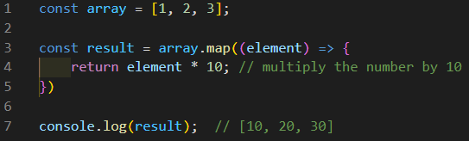
.filter | - Loops over an entire array.  - Good for removing unwanted data from the array.  - Return statement MUST be a condition or comparison. Returns elements that pass the condition / comparison.  - Returns a new array with filtered results. | 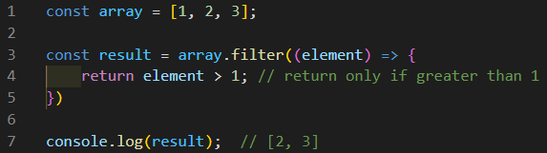
.every | - Loops over an entire array.  - Good for testing if all the data meets criteria.  - Return statement MUST be a condition or comparison.  - Returns a boolean (true or false). | 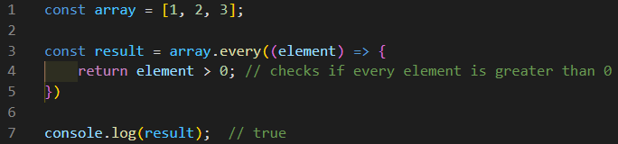
.find | - Loops over an entire array and stops when it finds a match.  - Good for finding a specific element.  - Return statement MUST be a condition.  - Returns the element if found.  - Returns undefined if the element is not found. | Worked:  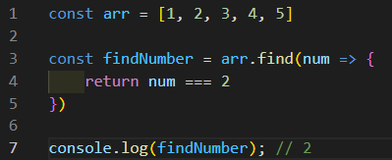  Failed:  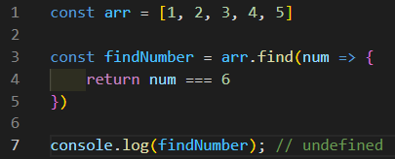

2.4 Object Specifics

2.4.1 Getting Values from Objects
Method | Use | Screenshot
dot notation  . | - Structure: object.key.  - Anything that comes after the . is considered by Javascript as a string.  - It will search in the object for a key with a name that matches whatever comes after the dot. | 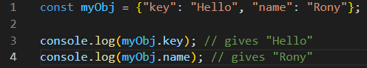
bracket notation  ["string"] | - Structure: object["key"].  - A string inside the [] is taken at face value.  - It will search in the object for a key named "key". | 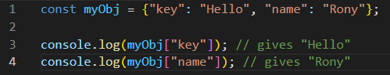
bracket notation  [variable] | - Structure: object[variable].  - A variable inside the [] is translated to its value.  - It will search in the object for a key that has the same name as the value of the variable. | 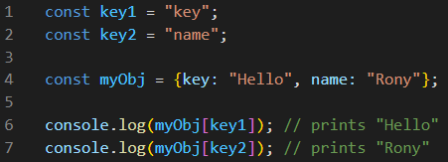

2.4.2 Object Methods
Because objects cannot be directly looped on, we can use the object methods to transform them into an array and loop over that array instead, indirectly looping on the object.
Method | Use | Screenshot
Object.keys | - Structure: Object.keys(object).  - Special method that returns all the keys inside the object in an array. | 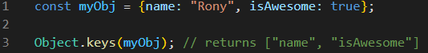
Object.values | - Structure: Object.values(object).  - Special method that returns all the values inside the object in an array. | 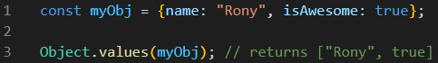

2.4.3 Destructuring
{variable} | - Assigns a variable to the value of a specific key inside an object.  - At declaration, the variable MUST be encased in {}.  - Declared variable’s name MUST match the keyin the object.  - Faster (and lazier) than doing:  - variable = object.key.  - variable = object[key].  - variable = object["key"]. | 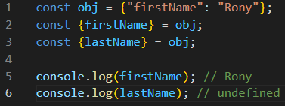

2.4.4 Creating New Key/Value Pairs
Creating a new key:value pair can be done with all 3 of the previous object notations.
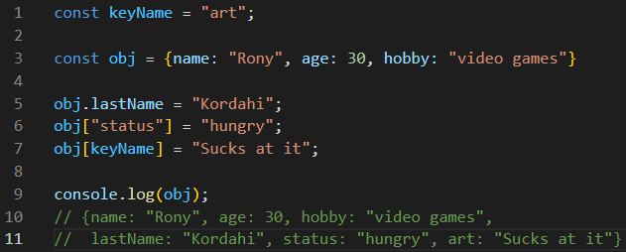
You can also use these methods to overwrite existing keys with new values:
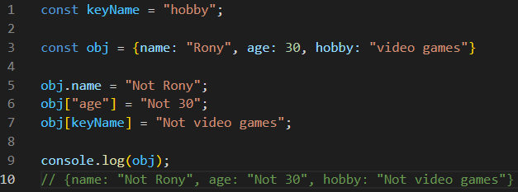

2.5 Function Specifics
To call a function, you need to first declare it, then you need to put its name followed by parenthesis.
Example: nameOfFunction();

parameter | - Variable that captures the value passed to a function when it is called.  - A parameter can be any type.  - A parameter only exists inside the function. | Classic:  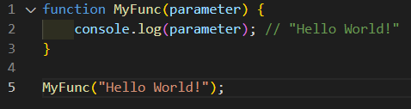  Arrow:  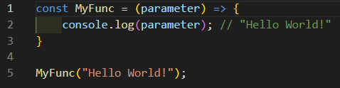
argument | - Value passed to a function when it is called.  - An argument can be any type.  - An argument does not need to be a variable. | Classic:  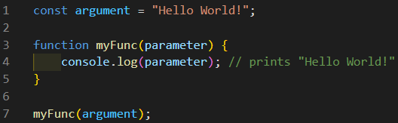  Arrow:  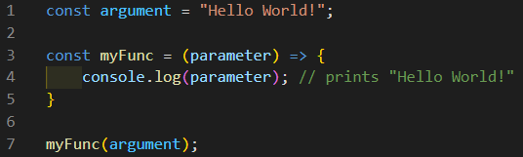
Callback function | - A function that is passed as a parameter or argument (usually to a method).  - Can be either named or unnamed.  - Unnamed functions are also called anonymous functions.  - Named functions do not need an argument AS LONG AS the parameter is defined. ONLY WORKS WITH A SINGLE PARAMETER AND ARGUMENT! IF MULTIPLE PARAMETERS AND ARGUMENTS ARE REQUIRED, YOU NEED TO DECLARE THEM! | Unnamed:  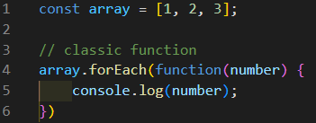  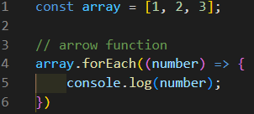  Named:  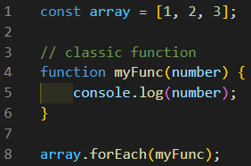  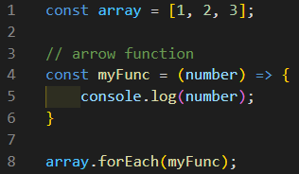

2.6 Method Specifics
Method parameter | - Value that is passed to a method when it is called.  - Technically these are arguments, but the term parameter is used interchangeably for methods. | 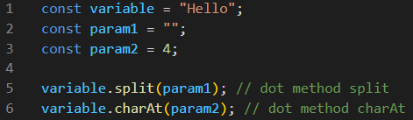
In-place modification | - Certain methods (such as splice) do what is known as an in-place modification.  - What this means is it overwrites the original variable.  - If a method does in-place modifications, there is no need to store the result because the original has been modified already. | 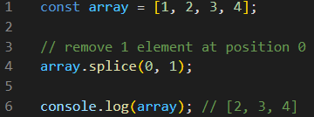

2.7 True and False specifics

2.7.1 True and Truthy

Type | Use | Screenshot
true | - Used in condition checks to trigger code.  - If a condition is true, it will happen.  - Any condition that is true is treated as type true. | 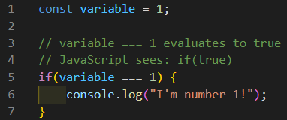
truthy | - Truthy is used to check for non-null values.  - Truthy values are "true non-true" values.  - This means that the condition is true, without being the type true.  - No need for == or === when looking at true/truthy elements. | 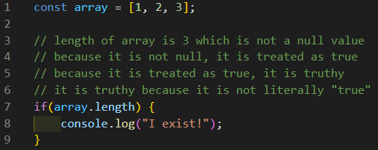

2.7.2 False and Falsy

Type | Use | Screenshot
false | - Used in condition checks to trigger code.  - If a condition is false, it will not happen.  - Any condition that is false is treated as type false. | 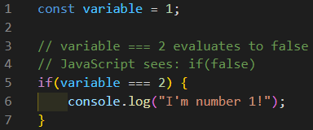
falsy | - Falsy is used to check for null values.  - Falsy values are "false non-false" values.  - This means that the condition is false, without being the type false.  - No need for == or === when looking at true/truthy elements. | 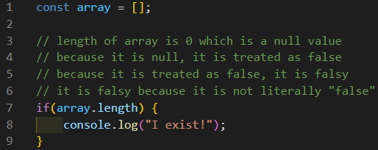

2.8 Loop Specifics

2.8.1 Types of Loops
***These are not the only loops. These are just the more widely used.***

Type | Use | Screenshot
for | - Used to run a piece of code a set number of times.  - Mostly used to iterate on arrays.  - When used on an array, the loop will run array.length number of times.  - Checks the condition before executing the code.  - A counter is always used in the condition.  - By convention, the variable created by the for loop is called i, short for index because we are using it to look at an array’s index.  - If nesting a for inside another, do not use i in the second loop! | Set number:  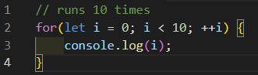  Array:  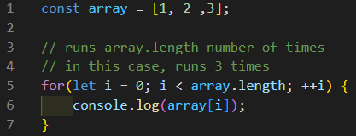
while | - Used to run a piece of code as many times as necessary.  - Checks the condition before running the code.  - Typically a flag or a counter is used for the condition. | 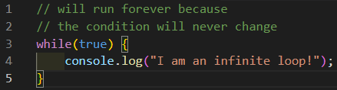  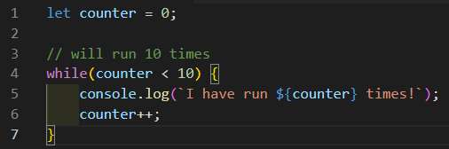
do... while | - Used to run a piece of code as many times as necessary.  - Checks the condition AFTER running the code at least once.  - Typically a flag or a counter is used for the condition. | 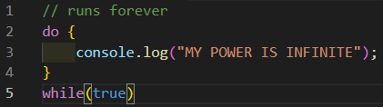  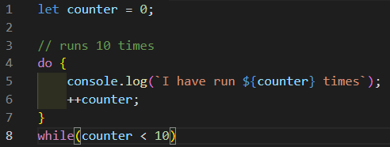

2.8.2 Loop Extras

Type | Use | Screenshot
break | - Used to kill a loop completely.  - Only kills the loop it’s in. If the loop is nested within another, the outer loop will not be affected.  - Similar to return, any code that comes after break will not be executed. | 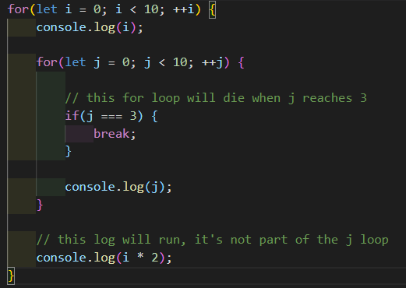
continue | - Used to skip the current iteration of a loop.  - Only affects the loop it’s in. If the loop is nested within another, the outer loop will not be affected.  - Similar to return, any code that comes after continue will not be executed. | 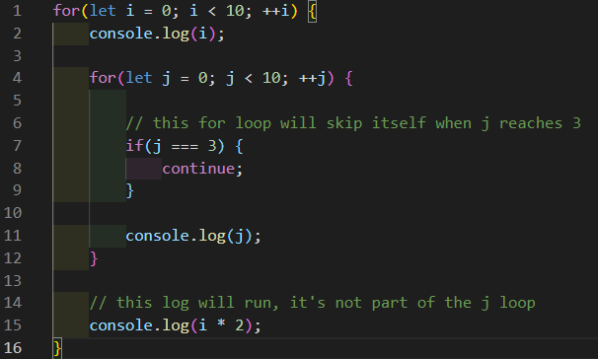

3. Coding Norms

3.1 Naming Convention

Norm | Use | Screenshot
variables  and  functions | - Relevant names keeps the code clear and easy to understand.  - Ex: naming variables to reflect what they contain or check for.  - Ex: naming functions to reflect what they do.  - Ex: naming parameters to reflect what they receive / contain. | Variables:  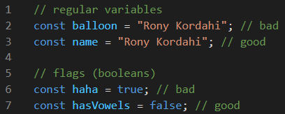  Functions:  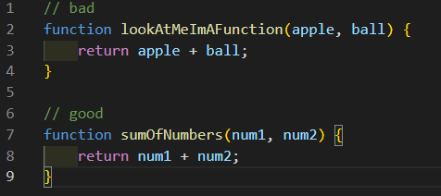
camelCasing | - Camel casing improves readability.  - If a variable or function name contains multiple words, each new word’s first letter should be capitalized. | 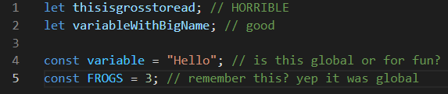
arrays  (highlights also apply to objects) | - Same rules as for variables, naming arrays to reflect what they contain makes things clear.  - Because arrays contain multiple instances of something, they are usually plural.  - For array methods, because they iterate on a single element in an array, it is best to name the parameter accordingly.  - Because the single element is one instance, it is usually singular.  - Parameters in the array method CANNOT have the same name as the array. | 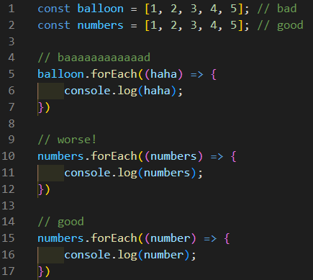

3.2 Clarity and Order

3.2.1 Clarity

Norm | Use | Screenshot
Spacing | - Keeps the code clean and easy to read/look at.  - Separate code from operators.  - Separate blocks of code from each other based on purpose or type. | 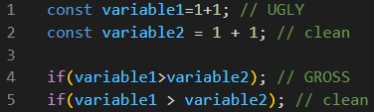  Notice how the variable declarations are separated from the ifs
Semi-colon  ; | - Goes after every line of code.  - CANNOT be put after an open bracket.  - Tells Javascript / CSS where the line ends (IMPORTANT).  - Also lets people who read your code where a line ends. | Javascript:  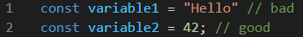  CSS:  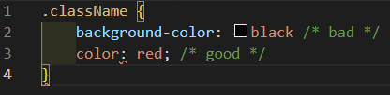  CSS (error):  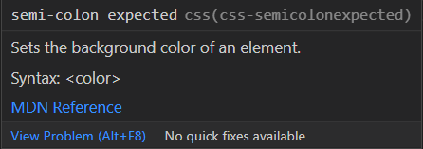

3.2.2 Order

Norm | Use | Screenshot
Declaration | - Keeps things organized and easy to find.  - Order should be as follows  - Variables  - Global  - Regular  - Functions  - Everything else | Notice the spacing between the different types  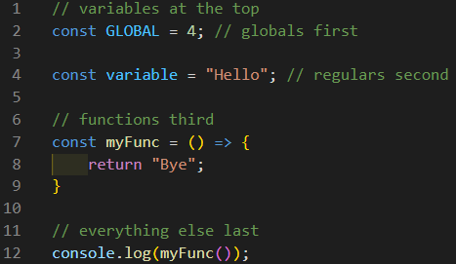

3.2 Indentation
- Keeps code clean and easy to read.
- Any code that is on the inside (usually inside curly brackets {}) MUST BE INDENTED.
  - "On the inside" applies to functions, loops, and operators (if, else if, else), and to HTML and CSS as well.
- For the love of whatever you hold dear, indent your code. Or I will inflict pain on you!
- Get the extension "indent-rainbow" on VSCode. It is free and color codes your indentations so you can keep track easier. This is now part of VSCode by default! You have no excuses!
- For the love of whatever you hold dear, indent your code. (yes I put it again)
- Code must be indented once for each element they are inside of (see nested examples below).

3.2.1 Simple examples
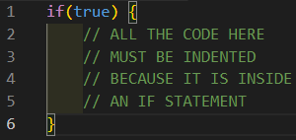
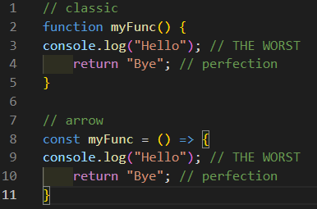
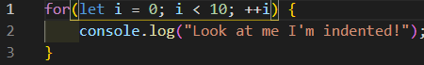

3.2.2 Nested examples
Look how pretty indent-rainbow makes things (with indentation spacing of 4)
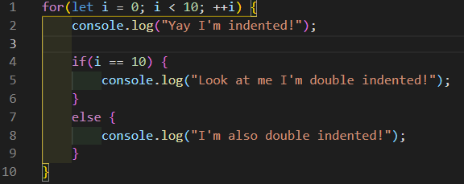
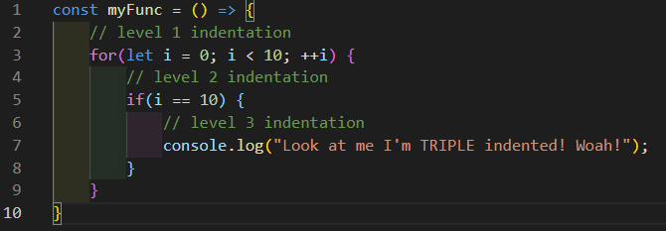
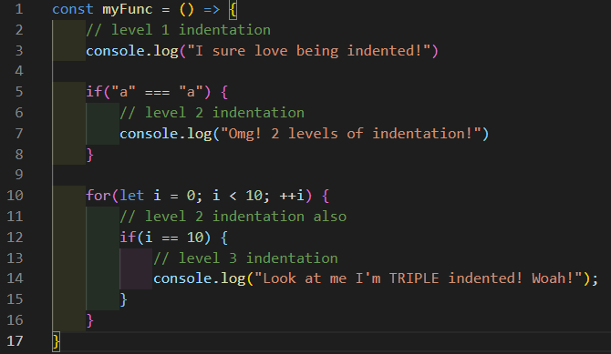

3.2.3 HTML
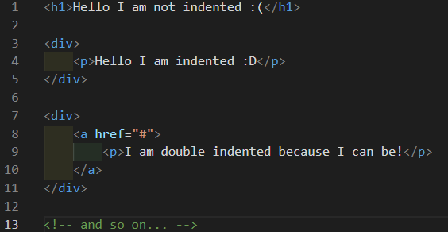

3.2.4 CSS
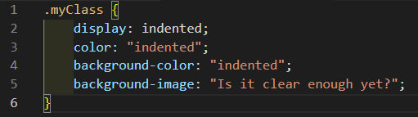

4. Cool Shortcuts
***Please note I use Windows and do not know the MAC versions. If you do know them let me know and I will add them in***

Windows Shortcut | Mac Shortcut | Use | Screenshot
CTRL + C  (copy) | Command + C | - Copies selected elements.  - Not limited to VSCode.  - In VSCode, can use shortcut to copy a whole line without highlighting it. | ~Use your imagination~ (nothing happens when doing this)
CTRL + X  (cut) | Command + V | - Deletes and copies selected elements.  - Not limited to VSCode.  - In VSCode, can use shortcut to cut a whole line without highlighting it. | ~Use your imagination~ (it deletes the original line and copies it, there would be nothing to screenshot)
CTRL + V  (paste) | Command + X | - Pastes copied elements.  - Not limited to VSCode.  - In VSCode, if a whole line was copied/cut, using the shortcut will paste it exactly as it was. | Before:  After:
CTRL + ]  or  TAB | Command + ]  or  TAB | - Indents forward by 1.  - Can highlight multiple lines to indent everything at once.  - NOTE: TAB only works on highlighted lines (both single or multiple). | Before:  After:
CTRL + [  or  SHIFT + TAB | Command + [  or  SHIFT + TAB | - Indents backwards by 1.  - Can highlight multiple lines to indent everything at once.  - NOTE: SHIFT + TAB only works on highlighted lines (both single or multiple). | Before:  After:
ALT + up arrow | ALT + up arrow | - Shifts code up by 1.  - Can highlight multiple lines to shift everything at once. | Before:  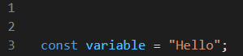  After:  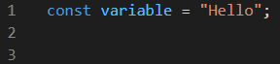
ALT + down arrow | ALT + down arrow | - Shifts code down by 1.  - Can highlight multiple lines to shift everything at once. | Before:  After:  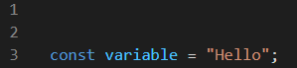
CTRL + D | Command + D | - Highlights word cursor is currently in.  - Hitting the shortcut again highlights the next instance of the word.  - Can edit all highlighted instances at once (~magic~). | Once:  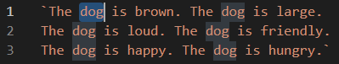  4x:  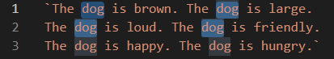
CTRL + SHIFT + L | Command + SHIFT + L | - Highlights all instances of the word in the file.  - Can edit all highlighted instances at once (~magic~). | No edit:  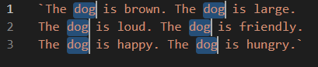  Edit: (notice multiple cursors)  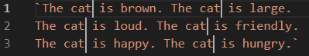
CTRL + / | Command + / | - Comments out current line.  - Can highlight multiple lines to comment out everything at once.  - Works for almost every IDE (Integrated Development Environment).  - An IDE is the platform you use to code with (we use VSCode).  - Can be used to uncomment too. | Before:  1x:  multiple:  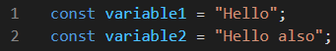  After:  1x:  multiple:  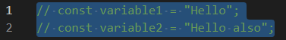
SHIFT + CTRL + left/right arrow | SHIFT + Command +  left/right arrow | - Highlights the code in one direction until the end is reached.  - Not limited to VSCode. | Before:  After:
Highlight + quotes or brackets | Highlight + quotes or brackets | - Quick encapsulation.  - Can be used to quickly encapsulate highlighted elements in quotes or brackets.  - Highlight what you want to encapsulate and press the needed brackets and/or quotes.  - If applying multiple modifications (Ex: quotes and brackets) do the outer level first (see last 2 pictures in After section of screenshots, square bracket before quotes). | Before:  After:

